**Converting between mixed numbers and improper fractions**

Mixed numbers and improper fractions are different ways of expressing fractions greater than 1. Mixed numbers are commonly used in everyday language when talking about quantities such as time, mass, and other measurements. For example, you might hear phrases like "one and a half kilos" or "two and three-quarter miles". This article will guide you through what mixed numbers and improper fractions are, and how to convert between these two forms.

**Improper fractions**

In contrast to proper fractions, improper fractions are identified as fractions that have a numerator greater than the denominator. This simply is a representation of quantities that are present in amounts greater than a whole.

Let’s imagine the diagram below shows the amount of pizza left over after a party. What is the quantity available as a fraction of a whole pizza?

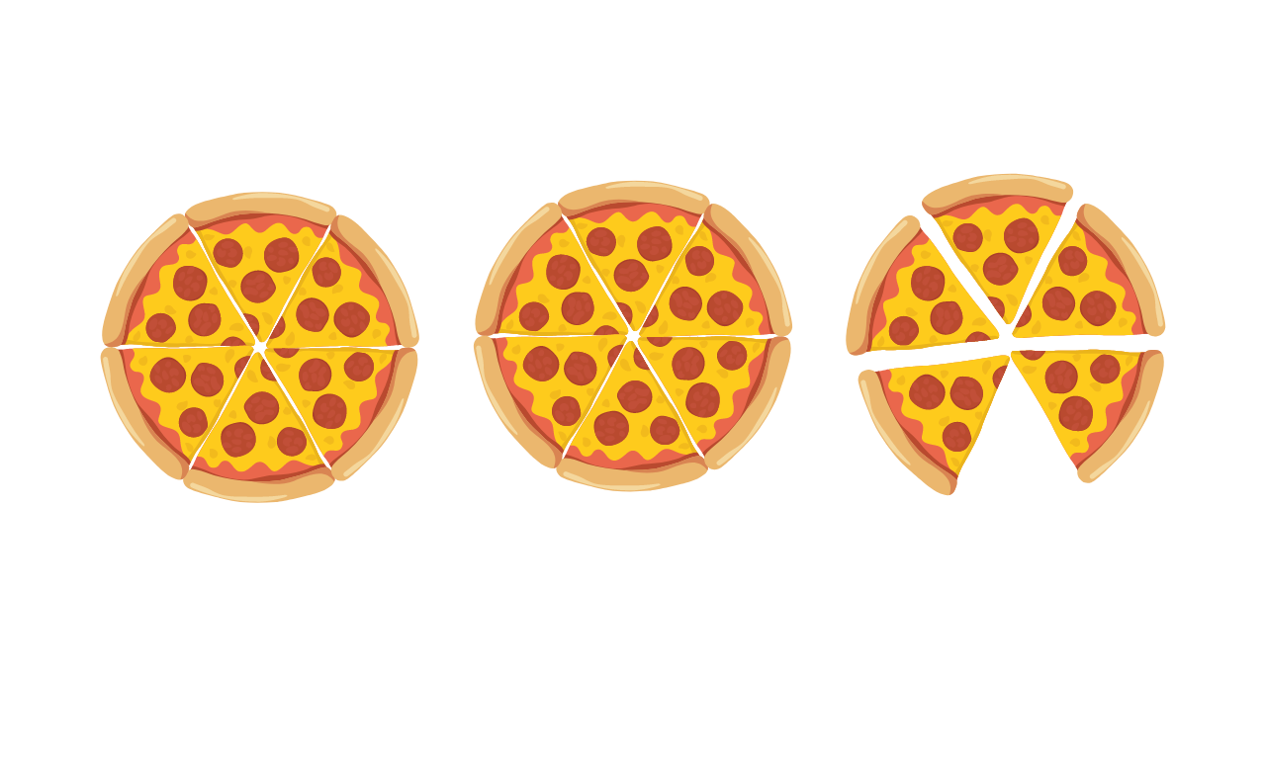

We can see that each whole pizza is broken down into sixths, hence each slice is ⅙ of a whole pizza. Now there’s a total of 17 such slices on the table. So that can be represented as 17/6.

Maybe a more intuitive way to represent this is by considering the number of whole pizzas separately and the remaining as a fraction. This is exactly what mixed numbers do.

**Mixed numbers**

Mixed numbers use a format that separates the number of wholes from the parts.

For the pizza example, we can say that there are 2 whole pizzas and 5 sixths remaining. Hence, the mixed number is written as $2\frac{5}{6}$.

$\frac{17}{6}$ and $2\frac{5}{6}$ represent the same quantity.

How can we convert between improper fractions and mixed numbers?

**Improper fraction to mixed number**

An improper fraction can be converted to a mixed number by dividing the numerator by the denominator. The quotient will be the number of wholes, and the remainder is the numerator of the fractional part of the mixed number. Note that the denominator remains unchanged.

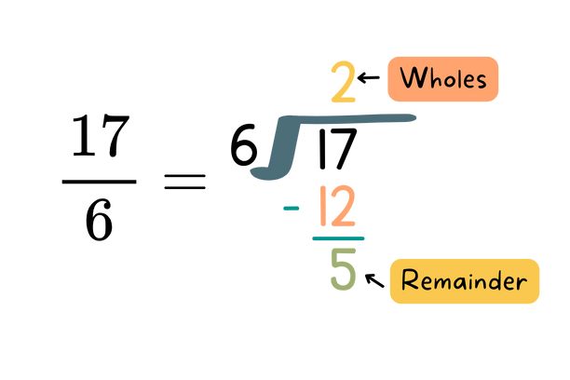

$17÷6 = 2 R5$

Therefore there are 2 wholes and 5 remainder. The mixed number is $2\frac{5}{6}$

**Mixed Number to improper fraction**

To convert a mixed number to an improper fraction, we can follow the steps below:

1. Multiply the denominator by the number of wholes
2. Add the result from step 1 to the numerator
3. The result of step 2 will be the numerator of the improper fraction
4. The denominator will remain unchanged.

The process of converting $2\frac{5}{6}$ into an improper fraction is shown below.

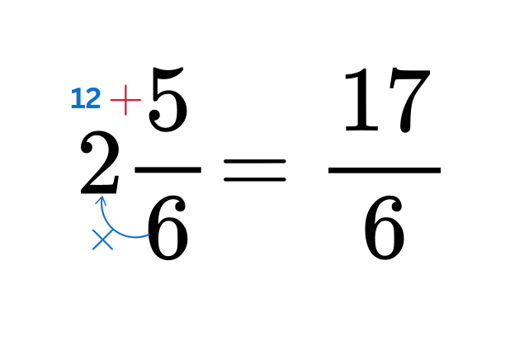

Challenge: Write 150% as a fraction and then convert it to a mixed number

A percentage is always out of 100.

150% = $\frac{150}{100}$

This is an improper fraction as the numerator is greater than the denominator.

To convert this into a mixed number we can simply divide the numerator by the denominator.

$150 ÷100 = 1 R50$

Therefore the mixed number is $1\frac{50}{100}$. By simplifying the fraction to its lowest form we get:

150% = $\frac{150}{100} = 1\frac{1}{2}$